### Setting up ServiceNow Instance

Duration: 1 Hrs

Skill Tags:

1. Sign up for a developer account on the ServiceNow Developer site “https://developer.servicenow.com”.
2. Once logged in, navigate to the "Personal Developer Instance" section.
3. Click on "Request Instance" to create a new ServiceNow instance.
4. Fill out the required information and submit the request.
5. You'll receive an email with the instance details once it's ready.
6. Log in to your ServiceNow instance using the provided credentials.
7. Now you will navigate to the ServiceNow.

### Creating a Update Set

Duration: 1 Hrs

Skill Tags:

* 1. Click on All >> Local update sets .

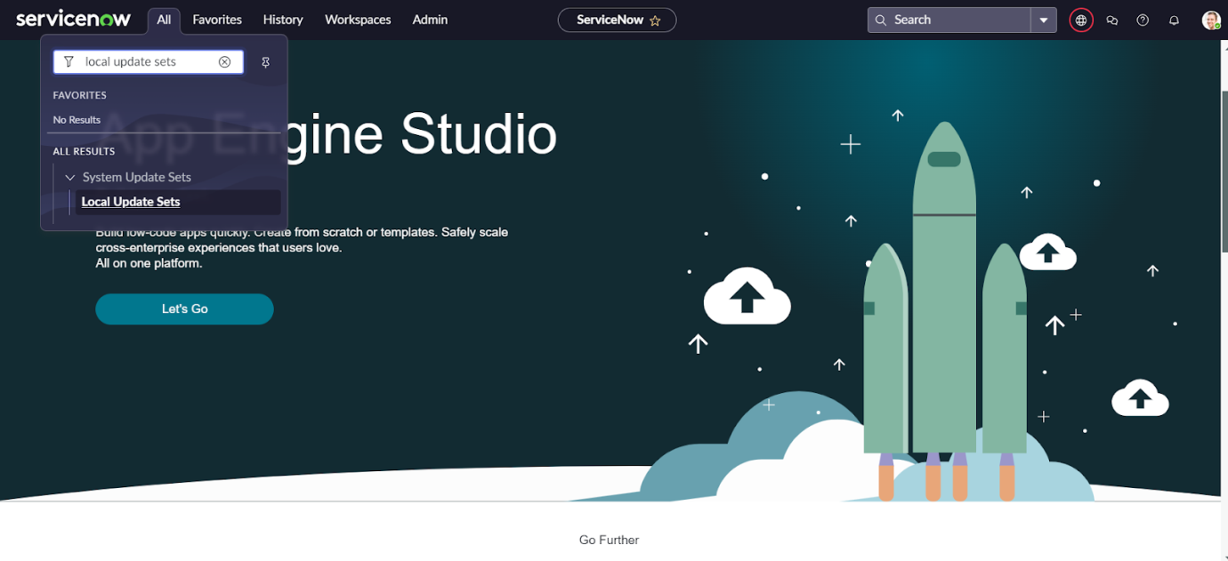

### Creating Salesforce Table.

Duration: 1 Hrs

Skill Tags:

* All >> Tables.

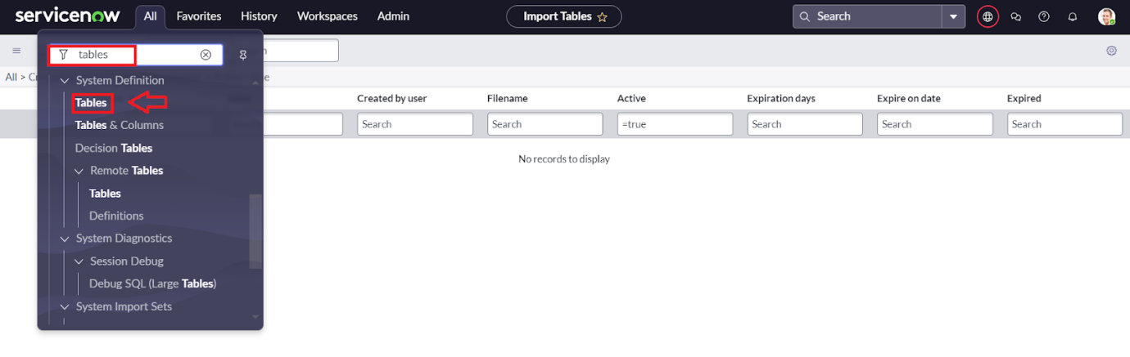

* Click on new

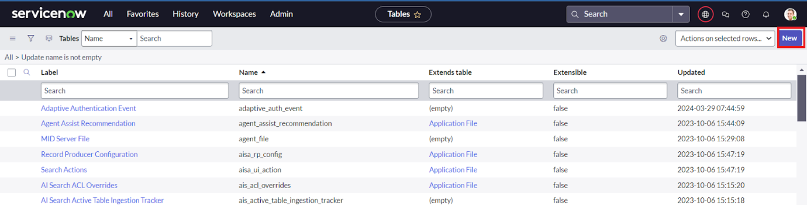

### Creating Admission Table

Duration: 1 Hrs

Skill Tags:

* Create an Admission Table with Columns given.
* Select Extends Table >> Salesforce and also Select Add module to menu >> Salesforce.
* Create Fields as shown

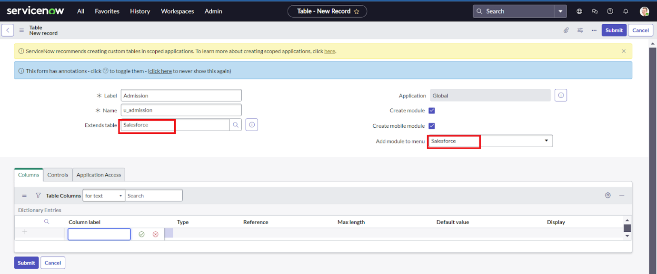

Creating Student Progress Table

Duration: 1 Hrs

Skill Tags:

* Create a Student Progress Table with Columns given.
* Select Add module to menu >> Salesforce.
* Create Fields as shown:

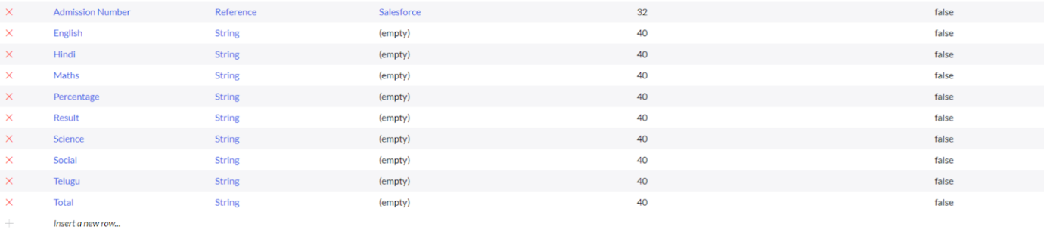

Configuring Table form for Student Progress Table

Duration: 1 Hrs

Skill Tags:

* In the Student Progress Table Page , Click on Layout form .

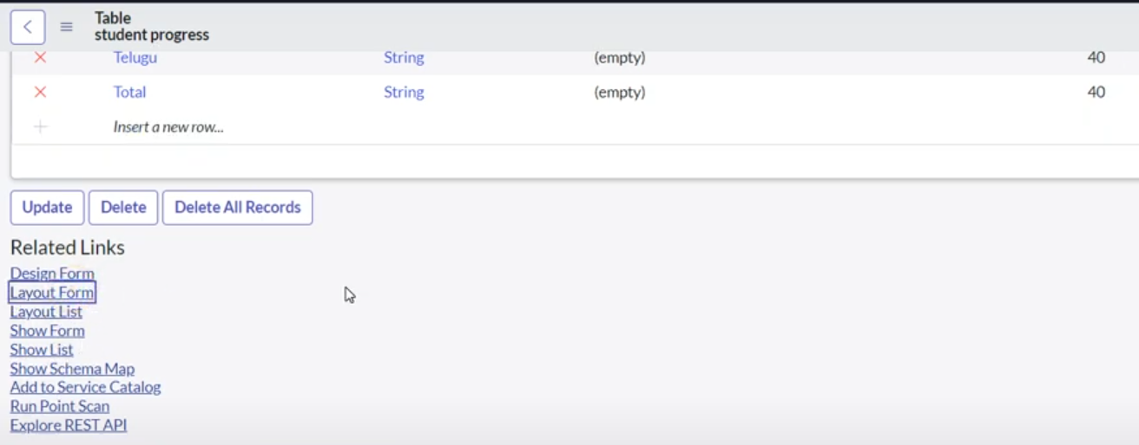

* Click on Admission Number [+] .

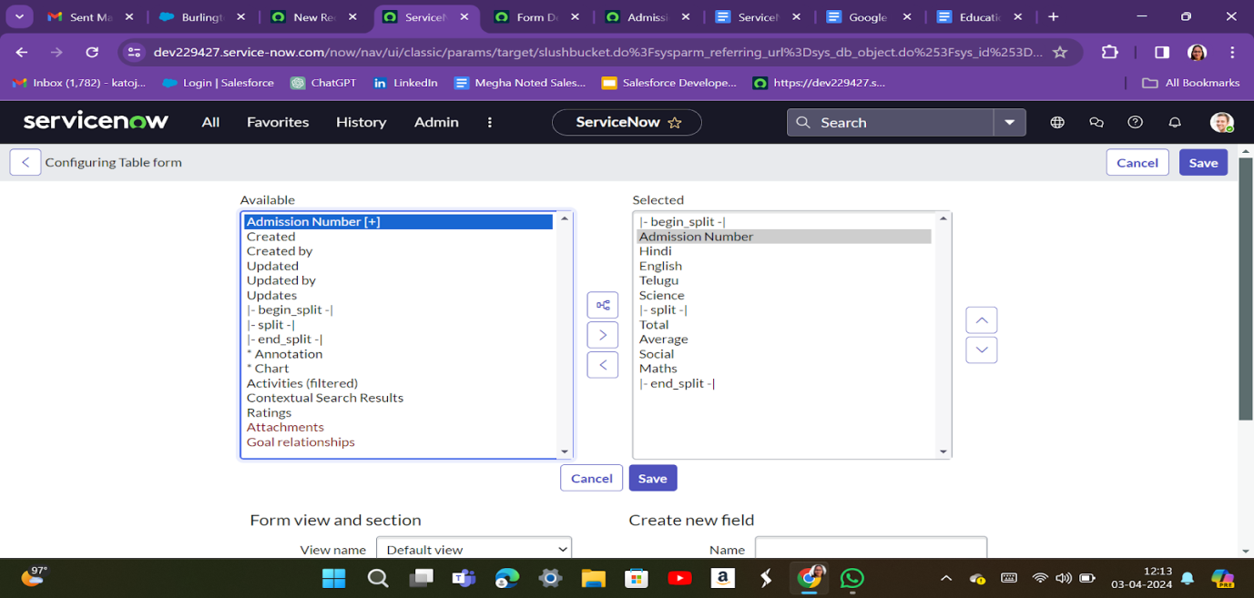

### Creating Form Design for Salesforce Table

Duration: 1 Hrs

Skill Tags:

1. All >> System Definition >> Tables .
2. In Label Search for Salesforce and open .

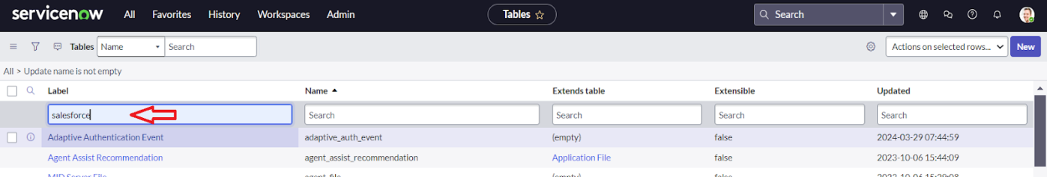

1. Right Click on top Toggle >> Configure >> Form Design.

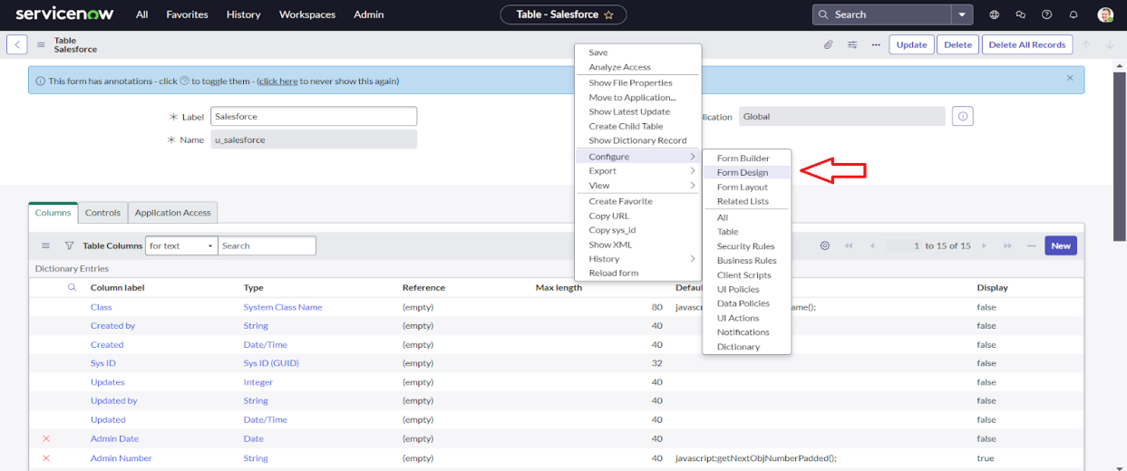

### Creating Form Design for Admission Table

Duration: 1 Hrs

Skill Tags:

Follow the same steps as Activity1,Configure the fields as below and Save.

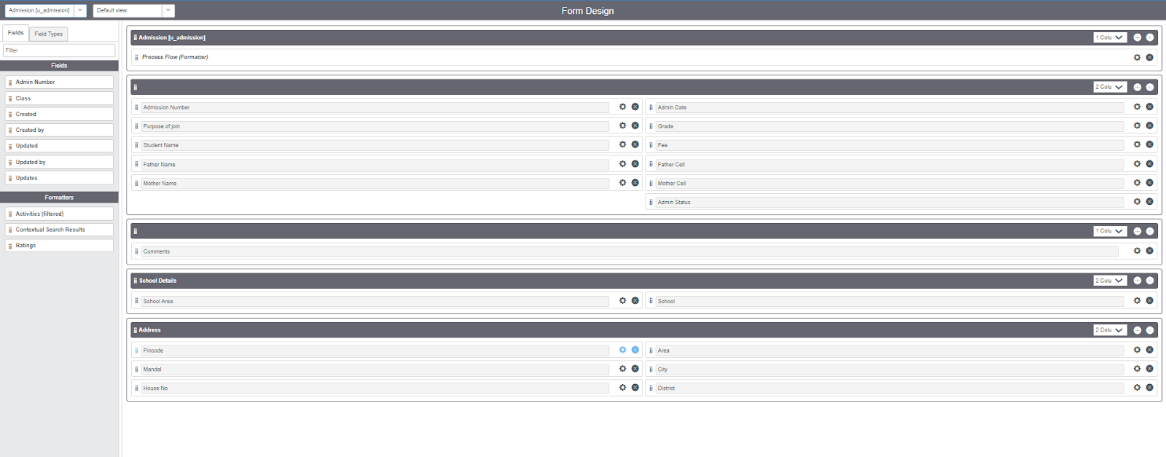

### Creating Form Design for Student progress Table

Follow the same steps as Activity1,Configure the fields as below and Save.

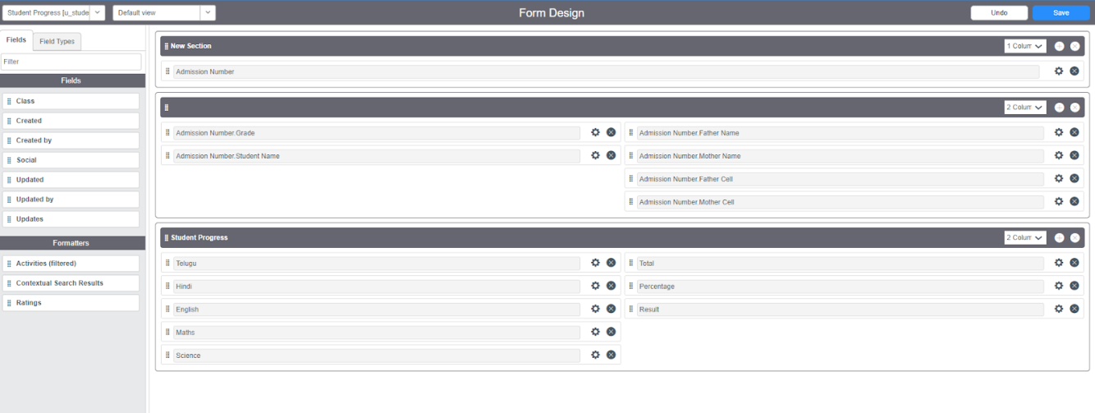

### Creating Number Maintenance for Admin Number

Duration: 1 Hrs

Skill Tags:

* All >> Number Maintenance >> New

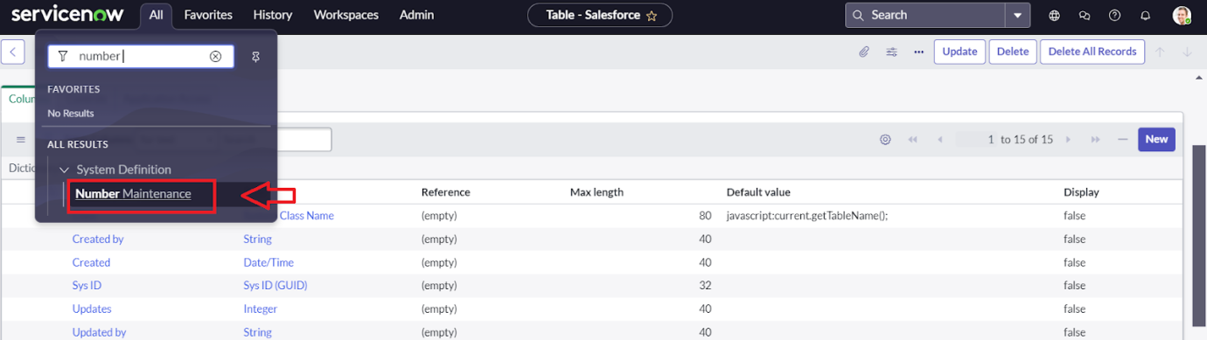

* Fill the details >> Submit.

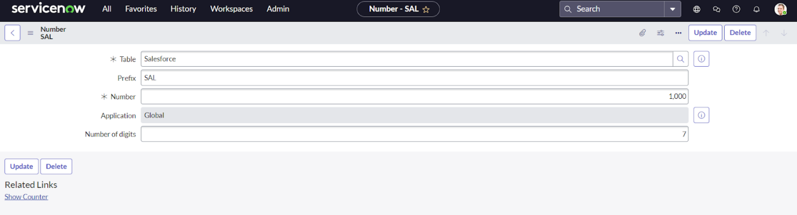

### Creating Process Flow for Admission Table

Duration: 1 Hrs

Skill Tags:

* All >> Process Flow>> New.
* Fill the Details as given Below

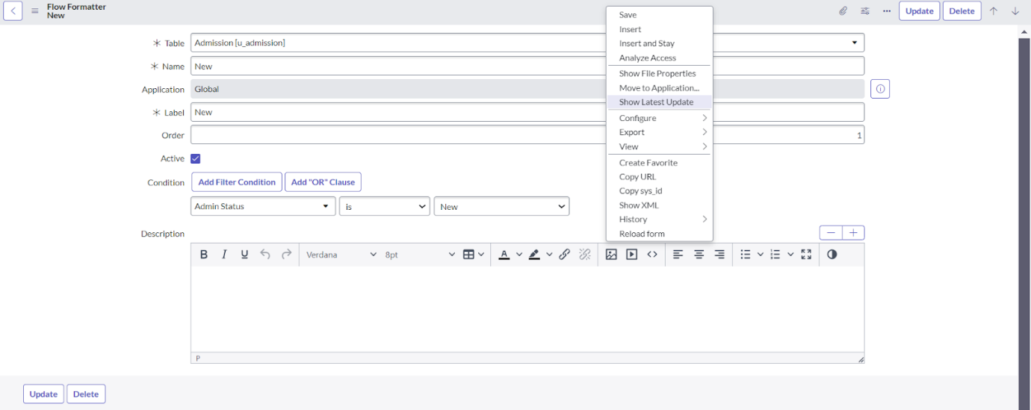

* Right Click on toggle and click on the save .
* Replace the Name and Label as below and click on Insert on stay.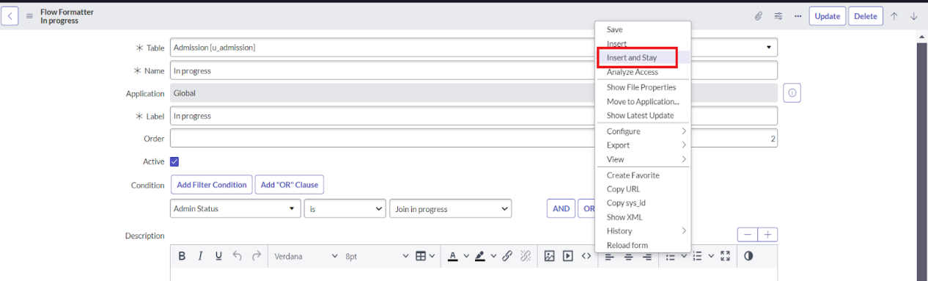

Creating “Auto populate” Client Scripts for Admission Table

Duration: 1 Hrs

Skill Tags:

* All >> Client Scripts >> New.
* Fill the Details as given.

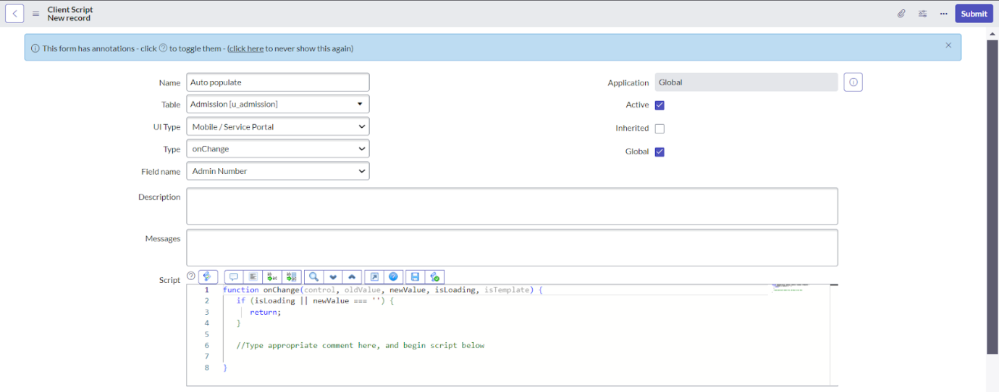

* Write the Code as below, Enable Isolate script and Save.

function onChange(control, oldValue, newValue, isLoading, isTemplate) {

   if (isLoading || newValue === '') {

      return;

   }

   //Type appropriate comment here, and begin script below

   var a = g_form.getReference('u_admission_number');

   g_form.setValue('u_admin_date',a.u_admin_date);

   g_form.setValue('u_grade',a.u_grade);

   g_form.setValue('u_student_name',a.u_student_name);

   g_form.setValue('u_father_name',a.u_father_name);

   g_form.setValue('u_mother_name',a.u_mother_name);

   g_form.setValue('u_father_cell',a.u_father_cell);

   g_form.setValue('u_mother_cell',a.u_mother_cell);

### Creating “Pincode Update” Client Scripts for Admission Table

Duration: 1 Hrs

Skill Tags:

* Fill the Details as given.

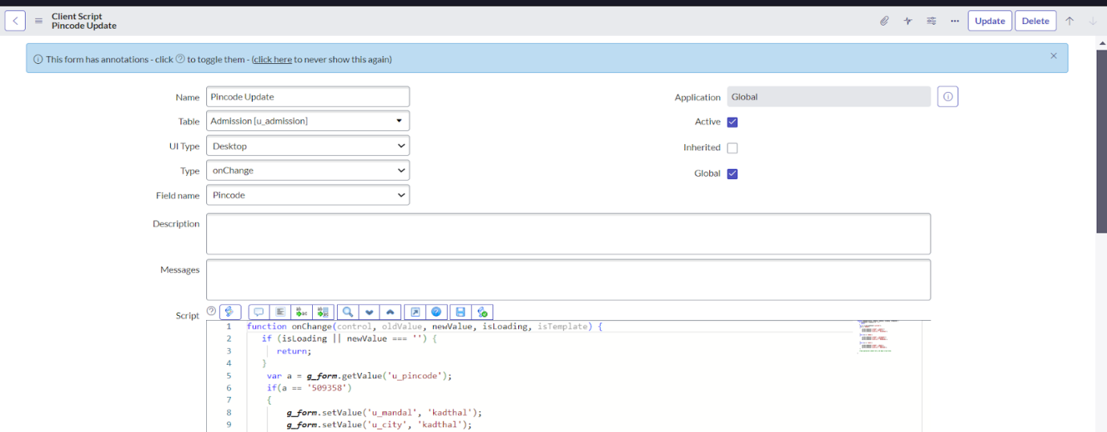

* Write the Code as below, Enable Isolate script and Save.

function onChange(control, oldValue, newValue, isLoading, isTemplate) {

   if (isLoading || newValue === '') {

      return;

   }

    var a = g_form.getValue('u_pincode');

if(a == '509358')

{

g_form.setValue('u_mandal', 'kadthal');

g_form.setValue('u_city', 'kadthal');

g_form.setValue('u_district', 'RangaRed

### Creating “Disable Fields” Client Scripts for Student progress Table

Duration: 1 Hrs

Skill Tags:

* Fill the Details as given.

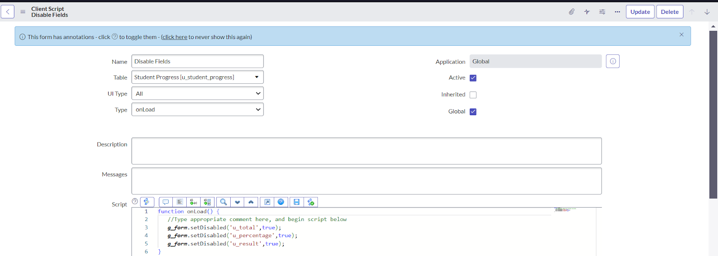

* Write the Code as below, Enable Isolate script and Save.

function onLoad() {

   //Type appropriate comment here, and begin script below

   g_form.setDisabled('u_total',true);

   g_form.setDisabled('u_percentage',true);

   g_form.setDisabled('u_result',true);

}

Creating “Total Update” Client Scripts for Student progress Table

Duration: 1 Hrs

Skill Tags:

* Fill the Details as given.

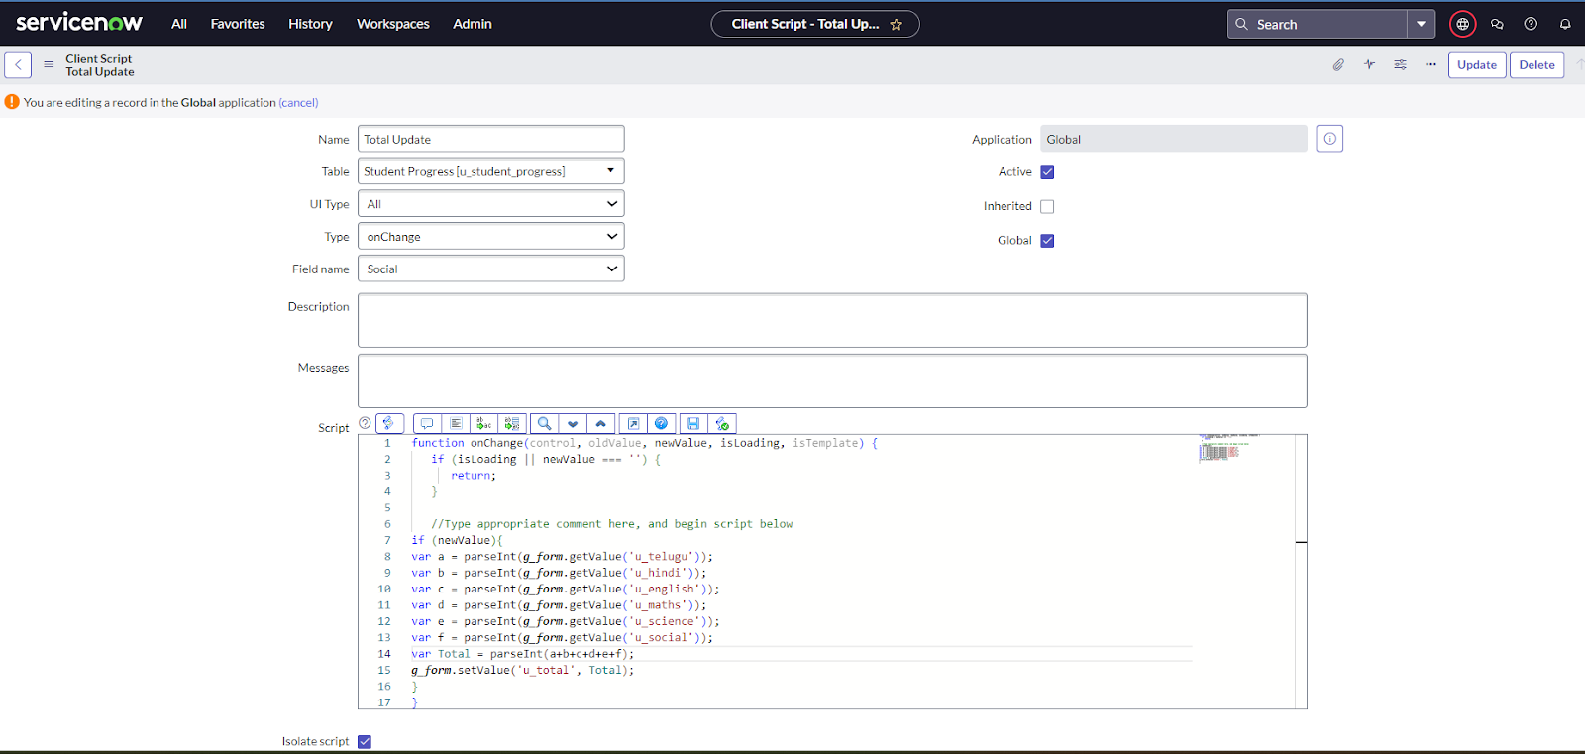

* Write the Code as below, Enable Isolate script and Save.

function onChange(control, oldValue, newValue, isLoading, isTemplate) {

   if (isLoading || newValue === '') {

      return;

   }

### Creating “Result” Client Scripts for Student progress Table

Duration: 1 Hrs

Skill Tags:

* Fill the Details as given.

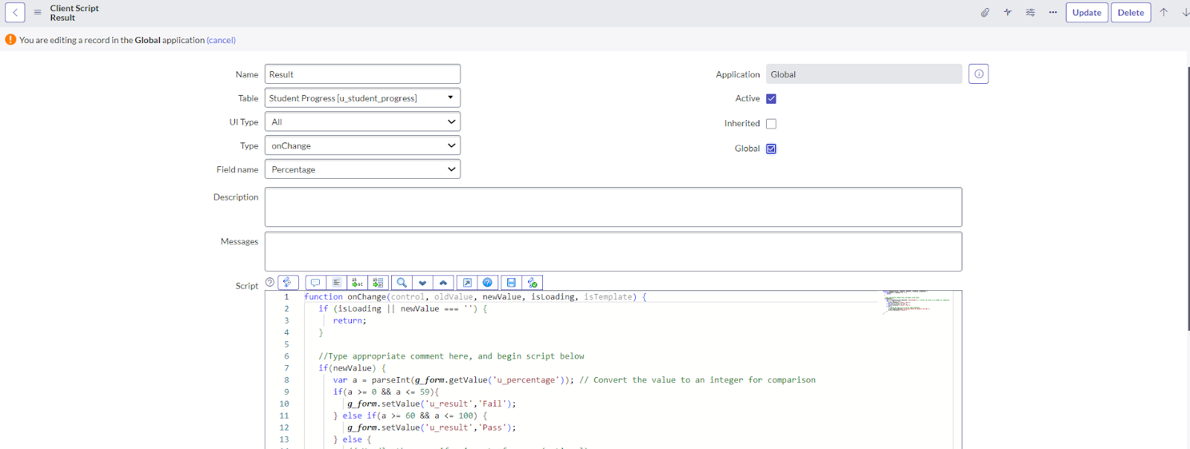

* Write the Code as below, Enable Isolate script and Save.

function onChange(control, oldValue, newValue, isLoading, isTemplate) {

   if (isLoading || newValue === '') {

      return;

   }

   //Type appropriate comment here, and begin script below

   if(newValue) {

      var a = parseInt(g_form.getValue('u_percentage')); // Convert the value to an integer for comparison

      if(a >= 0 && a <= 59){

         g_form.setValue('u_result','Fail')

### 

Creating “Percentage” Client Scripts for Student progress Table

Duration: 1 Hrs

Skill Tags:

* Fill the Details as given.

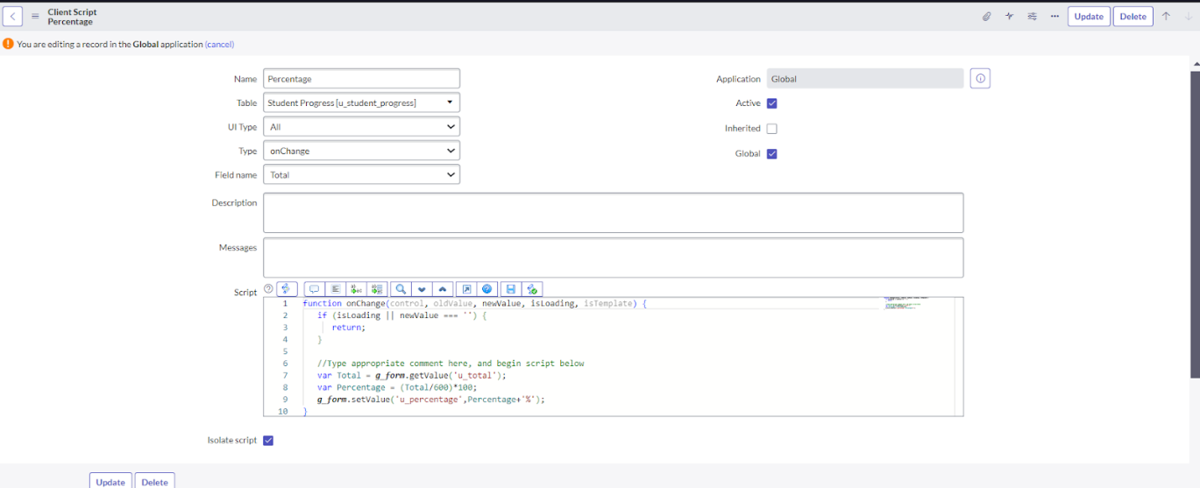

* Write the Code as below, Enable Isolate script and Save.

function onChange(control, oldValue, newValue, isLoading, isTemplate) {

   if (isLoading || newValue === '') {

      return;

   }

   //Type appropriate comment here, and begin script below

   var Total = g_form.getValue('u_total');

   var Percentage = (Total/600)*1

Result

